Name:- Anuradha Desale

Practical:-10

Roll no:-14 Sub:-DV

Case Study of Loan Prediction

import numpy as np # linear algebra

import pandas as pd # data processing, CSV file I/O (e.g. pd.read_csv)

# Input data files are available in the "../input/" directory.

# For example, running this (by clicking run or pressing Shift+Enter) will list the files in the input directory import matplotlib.pyplot as plt

%matplotlib inline import seaborn as sns

# Loading and Summarizing Data

train_data = pd.read_csv("train.csv") train_data.head()



|  |  |  |  |  |  |  |  |  |  |
| --- | --- | --- | --- | --- | --- | --- | --- | --- | --- |
| Loan_ID | Gender | Married | Dependents | Education | Self_Employed | ApplicantIncome | CoapplicantIncome | LoanAmount | Loan_Amount_Ter |
| 0 LP001002 | Male | No | 0 | Graduate | No | 5849 | 0.0 | NaN | 360. |
| 1 LP001003 | Male | Yes | 1 | Graduate | No | 4583 | 1508.0 | 128.0 | 360. |
| 2 LP001005 | Male | Yes | 0 | Graduate | Yes | 3000 | 0.0 | 66.0 | 360. |

3 LP001006 Male Yes 0 Not Graduate

No 2583 2358.0 120.0 360.

train_data.describe()

|  |  |  |  |  |  |
| --- | --- | --- | --- | --- | --- |
|  | ApplicantIncome | CoapplicantIncome | LoanAmount | Loan_Amount_Term | Credit_History |
| count | 614.000000 | 614.000000 | 592.000000 | 600.00000 | 564.000000 |
| mean | 5403.459283 | 1621.245798 | 146.412162 | 342.00000 | 0.842199 |
| std | 6109.041673 | 2926.248369 | 85.587325 | 65.12041 | 0.364878 |
| min | 150.000000 | 0.000000 | 9.000000 | 12.00000 | 0.000000 |
| 25% | 2877.500000 | 0.000000 | 100.000000 | 360.00000 | 1.000000 |
| 50% | 3812.500000 | 1188.500000 | 128.000000 | 360.00000 | 1.000000 |
| 75% | 5795.000000 | 2297.250000 | 168.000000 | 360.00000 | 1.000000 |
| max | 81000.000000 | 41667.000000 | 700.000000 | 480.00000 | 1.000000 |

# Distribution Analysis

train_data['ApplicantIncome'].hist(bins=70,grid=False)

<Axes: >

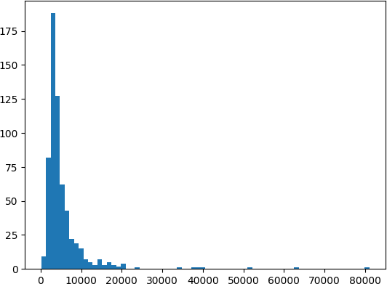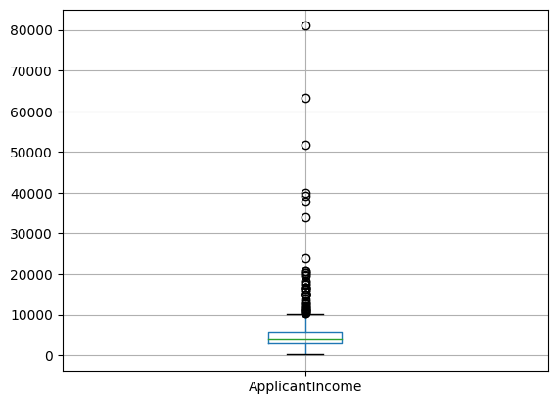

train_data.boxplot(column = 'ApplicantIncome')

<Axes: >

train_data.boxplot(column = 'ApplicantIncome', grid =False, by = 'Education')

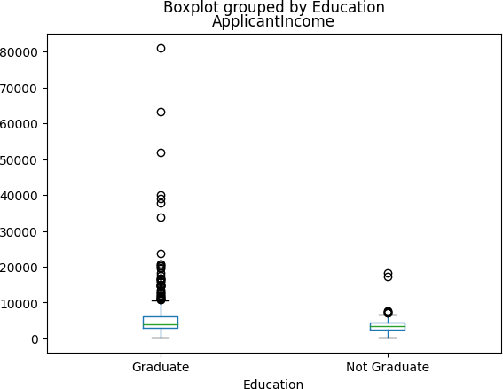<Axes: title={'center': 'ApplicantIncome'}, xlabel='Education'>

train_data['LoanAmount'].hist(bins=100,grid = False)

<Axes: >

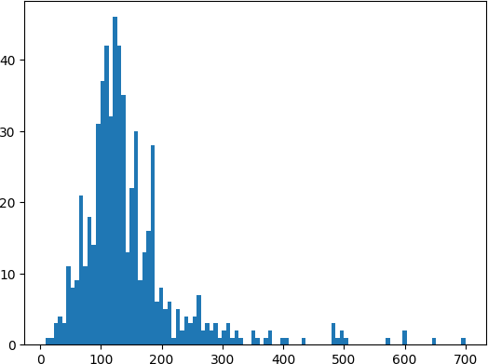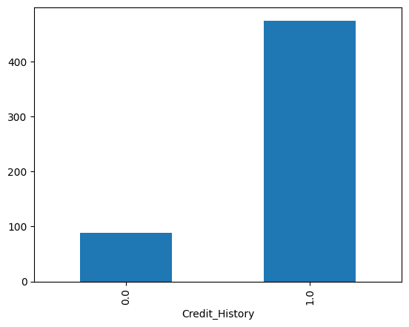

Categorical Value Analysis

temp = train_data['Credit_History'].value_counts(ascending = True) temp.plot(kind = 'bar')

<Axes: xlabel='Credit_History'>

# Data Munging

train_data.apply(lambda x: sum(x.isnull()),axis=0)

|  |  |
| --- | --- |
| Loan_ID | 0 |
| Gender | 13 |
| Married | 3 |
| Dependents | 15 |
| Education | 0 |
| Self_Employed | 32 |

ApplicantIncome 0

CoapplicantIncome 0

LoanAmount 22

Loan_Amount_Term 14

Credit_History 50

Property_Area 0

Loan_Status 0

dtype: int64

train_data['LoanAmount'].fillna(train_data['LoanAmount'].mean(),inplace=True)

train_data['Self_Employed'].fillna('No',inplace=True)

train_data['Gender'].fillna(train_data['Gender'].mode()[0], inplace=True) train_data['Married'].fillna(train_data['Married'].mode()[0], inplace=True) train_data['Dependents'].fillna(train_data['Dependents'].mode()[0], inplace=True)

train_data['Loan_Amount_Term'].fillna(train_data['Loan_Amount_Term'].mode()[0], inplace=True) train_data['Credit_History'].fillna(train_data['Credit_History'].mode()[0], inplace=True)

train_data.head()

|  |  |  |  |  |  |  |  |  |  |
| --- | --- | --- | --- | --- | --- | --- | --- | --- | --- |
| Loan_ID | Gender | Married | Dependents | Education | Self_Employed | ApplicantIncome | CoapplicantIncome | LoanAmount | Loan_Amount_Ter |
| 0 LP001002 | Male | No | 0 | Graduate | No | 5849 | 0.0 | 146.412162 | 360. |
| 1 LP001003 | Male | Yes | 1 | Graduate | No | 4583 | 1508.0 | 128.000000 | 360. |
| 2 LP001005 | Male | Yes | 0 | Graduate | Yes | 3000 | 0.0 | 66.000000 | 360. |

3 LP001006 Male Yes 0 Not Graduate

No 2583 2358.0 120.000000 360.

train_data.apply(lambda x: sum(x.isnull()),axis=0)

|  |  |  |
| --- | --- | --- |
| Loan_ID | 0 |  |
| Gender | 0 |  |
| Married | 0 |  |
| Dependents | 0 |  |
| Education | 0 |  |
| Self_Employed |  | 0 |

ApplicantIncome 0

CoapplicantIncome 0

LoanAmount 0

Loan_Amount_Term 0

Credit_History 0

Property_Area 0

Loan_Status 0

dtype: int64

from sklearn.preprocessing import LabelEncoder

var_mod = ['Gender','Married','Dependents','Education','Self_Employed','Property_Area','Loan_Status'] le = LabelEncoder()

for i in var_mod:

train_data[i] = le.fit_transform(train_data[i]) train_data.head()

|  |  |  |  |  |  |  |  |  |  |
| --- | --- | --- | --- | --- | --- | --- | --- | --- | --- |
| Loan_ID | Gender | Married | Dependents | Education | Self_Employed | ApplicantIncome | CoapplicantIncome | LoanAmount | Loan_Amount_Ter |
| 0 LP001002 | 1 | 0 | 0 | 0 | 0 | 5849 | 0.0 | 146.412162 | 360. |
| 1 LP001003 | 1 | 1 | 1 | 0 | 0 | 4583 | 1508.0 | 128.000000 | 360. |
| 2 LP001005 | 1 | 1 | 0 | 0 | 1 | 3000 | 0.0 | 66.000000 | 360. |
| 3 LP001006 | 1 | 1 | 0 | 1 | 0 | 2583 | 2358.0 | 120.000000 | 360. |
| 4 LP001008 | 1 | 0 | 0 | 0 | 0 | 6000 | 0.0 | 141.000000 | 360. |
|  |  |  |  |  |  |  |  |  |  |

# Training Model

X = train_data[['Credit_History','Gender','Married','Education']] y = train_data['Loan_Status']

from sklearn.tree import DecisionTreeClassifier model = DecisionTreeClassifier() model.fit(X,y)

predictions = model.predict(X)

from sklearn.metrics import accuracy_score print(accuracy_score(predictions,y))

0.8094462540716613